**Project Design Phase-I**

**Solution Architecture**

|  |  |
| --- | --- |
| Date | 19 September 2022 |
| Team ID | PNT2022TMID52749 |
| Project Name | Project -SMART SLOUTION FOR RAILWAYS |
| Maximum Marks | 4 Marks |

**Solution Architecture:**

* A web page is designed to book the train tickets between two destinations.
* The user receives the QR code via mail or message.
* The ticket collector can identify the personal information by scanning the QR code.
* The client booking information will be stored in the database with unique ID and it is retrievable.

**Example - Solution Architecture Diagram:**

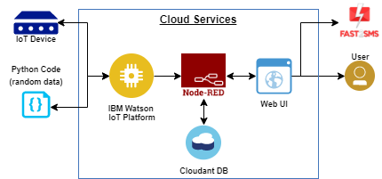

Figure 1: Architecture and data flow of the smart railways for solutions.

Figure 1: Architecture and data flow of the voice patient diary sample application

**Reference:** [**https://aws.amazon.com/blogs/industries/voice-applications-in-clinical-research-powered-by-ai-on-aws-part-1-architecture-and-design-considerations/**](https://aws.amazon.com/blogs/industries/voice-applications-in-clinical-research-powered-by-ai-on-aws-part-1-architecture-and-design-considerations/)